Genetec Camera Mapping Project
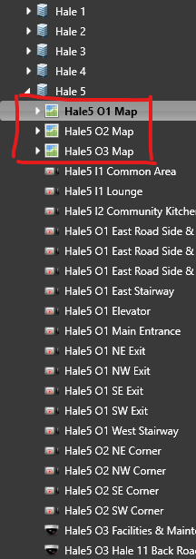
We added new entities to separate the map into the actual camera entities.
As shown above, we created three new entities in Hale 5 for Floors 1–3.
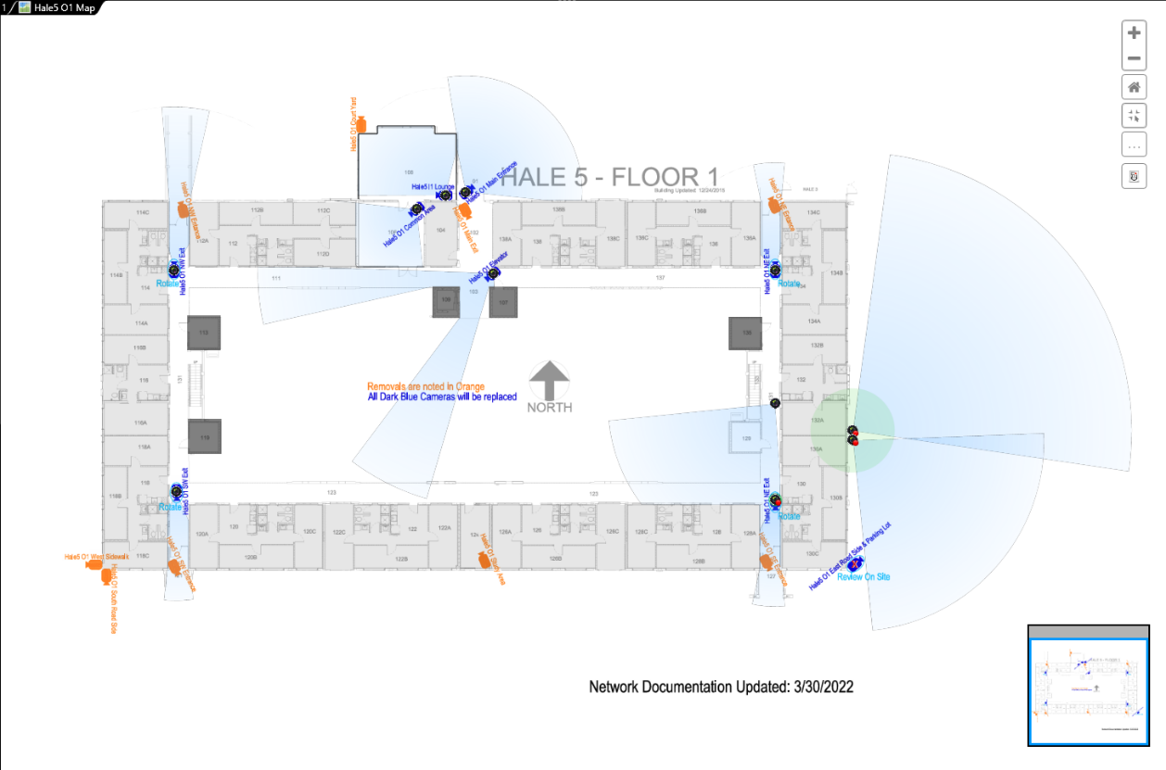
Each map looks like this. In Hale 5, we mapped all the cameras based on their actual positions, including the angle they are facing and their point of view, to better identify blind spots and assist with investigations.
Mapping Configuration (Standard)
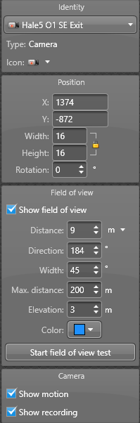
Cameras are responsive and working!!!
